Week 1 Module 1.2 Assignment
GitHub Repository Setup

Juan Macias Vasquez
Bellevue University
CSD440-H323 Server-Side Scripting (2265-DD)
Jack Lusby
March 27th, 2026

Week 1 Module 1.2 Assignment
GitHub Repository Setup
GitHub Repository
https://github.com/Juan551School/csd-440
Repository Set Up
Name: csd-440
Description: CSD440-H323 Server-Side Scripting (2265-DD)

Pictures of Steps Complete
Repository After being made
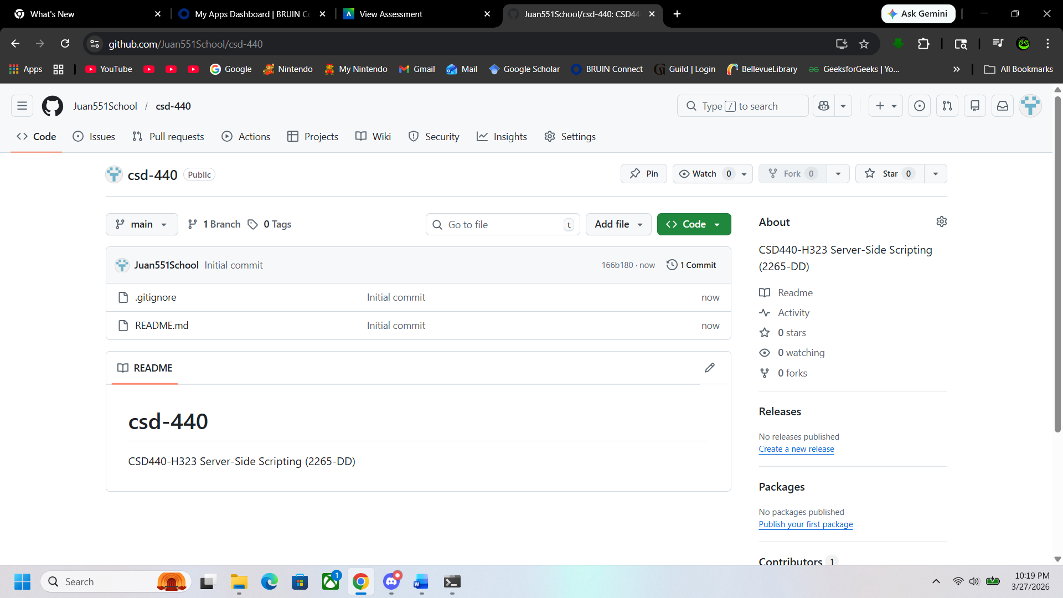

Repository Cloned in Command prompt
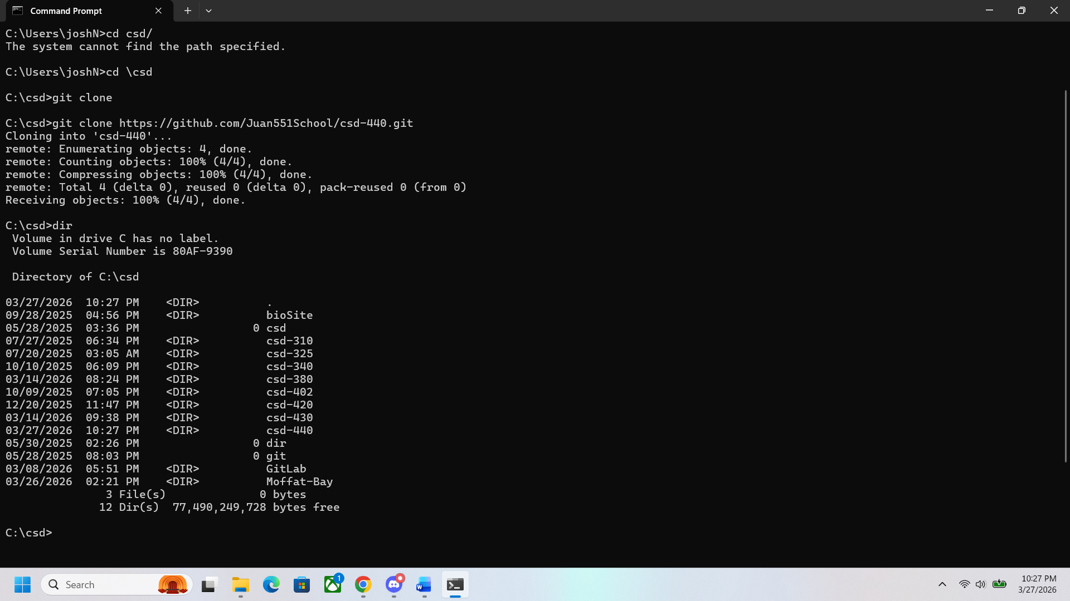

Picture of repository files on my computer
